Music management

system

Project

Submitted to

**Mam Atika Islam**

Submitted by

Ibraheem Qasim

42896

Sarmad Murtaza

42904

**School of Computing and Innovation**

Riphah International University, Lahore Campus.

1. **Introduction**

Imagine a magical place for music lovers! Our project is all about creating a super easy-to-use Music Management System. It's like having your own organized library where you can find, create, and share your favorite tunes hassle-free.

1. **Objective**

We want to make everyone's music experience better by building a system that helps you manage your music easily. Whether you're an artist or just love jamming out, our goal is to create a platform that makes finding and enjoying music a piece of cake.

1. **Problem Description**

**What:** Ever had trouble finding the right song or organizing your playlists? Our project solves exactly that!

**Why:** Because everyone deserves a simple way to manage their music. No more chaos in your playlists or struggling to discover new songs.

**How:** We're creating a system where you can easily create playlists, collaborate with others on music, and get awesome recommendations. Musicians, music fans, and industry folks – everyone gets a share of the music love.

1. **Software process model**

The software process I used to built this project is incremental model because the development of this software is separated into two phase , phase 1 and phase 2. So increment model is the best approach to meet the requirments.

**Why to use Incremental Model.**

* **Documentation of project is clear**
* **Early development and delivery**

**Advantages of increment model.**

* **Project will be delivered early and more updates will be added time to time**
* **Less costly as compared to other development model**

1. **Features**

- Click-and-Play Interface

- One-Click Playlist Creation

- Easy-to-Use Songwriting Tools

- Organize Music with Simple Tags

- Get Song Suggestions Based on Your Tastes

- Personalized User Profiles

- Collaborate with Artists Effortlessly

- Quick Genre Sorting

- Easy Sign-up and Log-in

- Access Anywhere, Anytime

1. **Users**

1. Music Lovers

2. Musicians

3. Artists

4. Anyone who enjoys a good beat!

1. **Requirements**
   1. **Easy Sign-up**
      1. Users should be able to sign up with just an email.
      2. Logging in should be as easy as clicking a button.
   2. **Playlist Magic**
   3. **Tag It Right**
   4. **Collaborative Jam**
      1. Users can invite others to collaborate on playlists.
      2. Real-time collaboration features for songwriting.
2. **References**

No reference added in this document

**Project – Phase 1**

In project phase 1 there are Functional Requirements , Non-Functional Requirements, Constraint Requirements and Domain Requirements

1. 10 Functional Requirements
2. 5 Non-Functional Requirements
3. 3 Constraints Requirements
4. 2 Domain Requirement

**Functional Requirements**

1. Easy Sign-up
2. Playlist Magic
3. Tag It Right
4. Collaborative Jam
5. Smart Recommendations
6. Personalized Profiles
7. Artist Collaboration Hub
8. Quick Genre Sorting

**Functional Requirements Description**

1. Easy Sign-up :

User will able to sign up with just an email and login in will be easy as clicking button.

1. Playlist Magic :

User can create a playlist by clicking at one button and also user can share playlist by sending a link

1. Tag it right :

Each song should be taggable with genre and mood. User can sort songs based on tags

1. Collaborative Jam:

User can invite other to collaborate on playlist and also Real-time collaboration features for songwriting

1. Smart Recommendations :

The system should suggest songs based on user preferences and Recommendations should get smarter with usage

1. Personalized Profiles :

Users can customize their profiles with pictures and bios.And profile show user most played genre

1. Quick Genre Sorting :

Users can easily filter songs by genre and provide icons for quick identification

1. Artist Collaboration Hub :

This fun have Dedicated spaces for artists to connect and collaborate and they can direct message and share file

**Non Functional Requirements :**

1. Lightning Fast
2. Keep It Safe
3. Intuitive User Interface
4. Scalability

**Non Functional Requirements Description :**

1. Lightning Fast :

The system should respond super fast, almost like magic.

1. keep it safe :

Your info should be super secure – like having a lock on your diary

1. Intuitive User Interface :

The system should be easy to navigate, even for first-time users.

1. Scalability :

The system should handle an increasing number of users and songs without slowing down

**Constraint Requirements :**

1. Size.
2. Time duration during development

**Domain Requirements :**

Accessibility Standards

**Project – Phase 2**

**Activity Diagram:**

The activity diagram of project is given below :

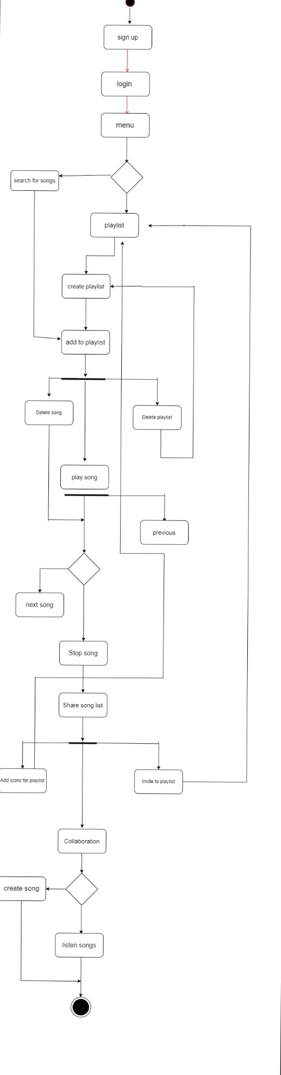

**Class Diagram :**

The class diagram of this project is given below.

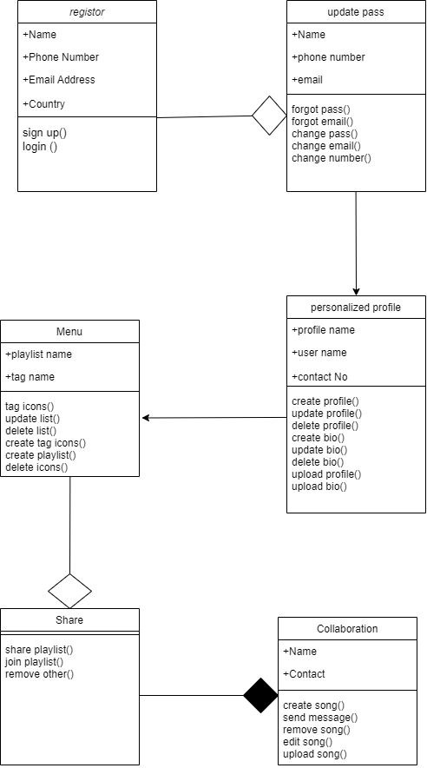

**Use case description :**

**Use case diagram :**

The use case diagram of this project is given below.

